The Rabbits
The Rabbits, written by John Marsden, is partly allegorical fable about colonisation, told from the viewpoint of the colonised. An unseen narrator describes the coming of ‘rabbits’ in the most minimal detail, an encounter that is at first friendly and curious, but later darkens as it becomes apparent that the visitors are actually invaders. The style of the book is deliberately sparse and strange, with both text and image conveying an overall sense of bewilderment and anxiety as native numbat-like creatures witness environmental devastation under the wheels of a strange new culture.
> Click here for further comment about The Rabbits.
> Click here for a interview about The Rabbits from 1998.
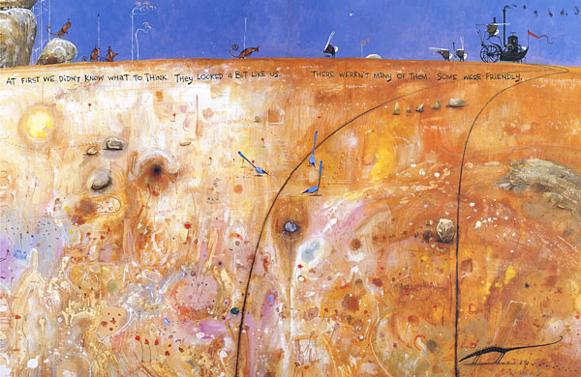

‘The meeting on the hill’ acrylic, gouache, ink and coloured pencil.
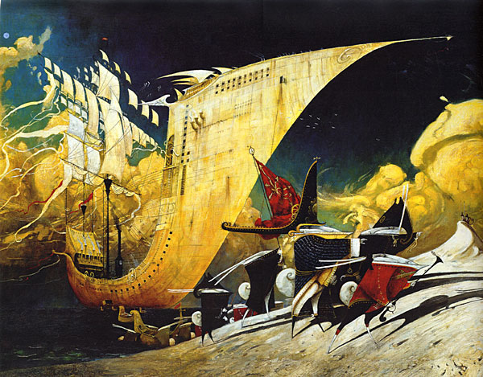

‘They came by water’ Oil on canvas.
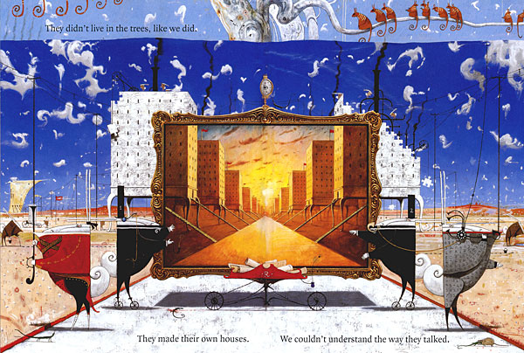

‘The building of the houses’ acrylic, gouache and coloured pencil.
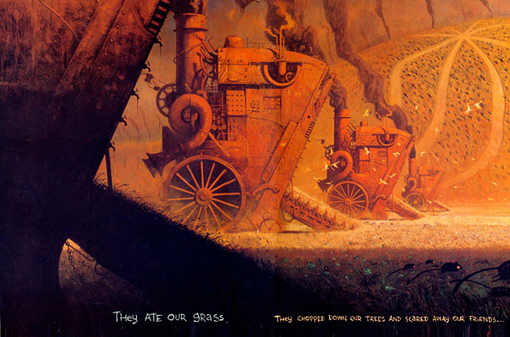

‘They ate our grass’ gouache and coloured pencil.

Comments on The Rabbits
The parallels with a real history of colonisation in Australia and around the world are obvious, and based on detailed research, in spite of the overt surrealism of the imagery and the absence of direct references. It was named Picture Book of the Year by the Children’s Book Council, which in part generated some controversy due to it’s confronting themes, and was attacked on several occasions for being ‘politically correct propaganda’, but only by right wing conservatives of course. In spite of this (or because of it), the book went on to win numerous awards in Australia, the US and UK, and is studied widely in secondary schools. It would seem that some of my concepts and designs were unacknowledged inspiration for a section of the opening ceremony of the 2000 Sydney Olympics, although I’ve never been able to find out if this is true.
One reason for the initial controversy is that The Rabbits is a picture book, and therefore thought to be children’s literature, and wrongly assumed to be didactic, whereas it had been originally conceived as a book for older readers, and generally difficult to categorise. Some children may get a lot out of it, but generally it defies most picture book conventions and is not necessarily a good choice for pleasant bedtime reading!

Allegory and Artwork in John Marsden and Shaun Tan’s “The Rabbits”
Posted on July 11, 2012 by Myra GB in Asian Literature and Immigrant Experience, Award-Winning, AWB (Award-Winning-Books) 2012, Book Reviews, GB Challenges, GB Reading Themes, Immigrant Stories Challenge 2012, Picture Book Challenge 2012, Picture Books, PoC Reading Challenge 2012, Reading the World 2012 // 13 Comments
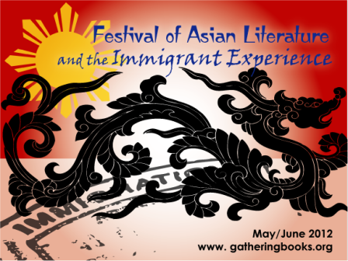
I didn’t realize when we launched our bimonthly theme “Festival of Asian Literature and the Immigrant Experience” – that it would lead me to amazing books such as the one recommended to me by Benjamin Farr from Tanglin Trust School (check out their library here). I thought I have read all of Shaun Tan’s books – apparently I missed out on a few, such as this one.
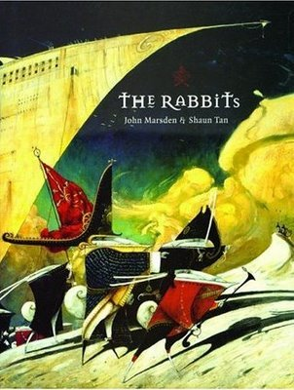
In most of the books that we have read which dealt with the immigrant experience, too often the stories are written from the perspective of the immigrant, the newcomer, the foreigner in the land. The reader is very seldom privy to what goes on in the heads of the ‘natives’.
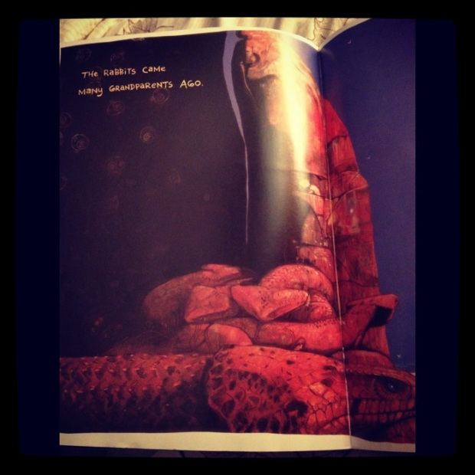
In John Marsden’s The Rabbits one hears the sharp, no-nonsense, powerful voice of the natives (depicted here as numbats) who regard the ‘rabbits’ with a measure of distrust, caution, resentment, defeat, despair, and overwhelming sense of disquiet – all spoken in a matter-of-fact tone that pierces one’s being to the core.
The narrative shows a linear, sequential progression with the rabbits arriving many grandparents ago (as seen in the photo above), and how the “old people warned us: be careful. They won’t understand the right ways” (see photo below) – to the rabbits slowly coming in by water, then through various means – as they bring new food and other animals – and how they spread across the countries – and the fights, oh, the fights which the numbats lost.
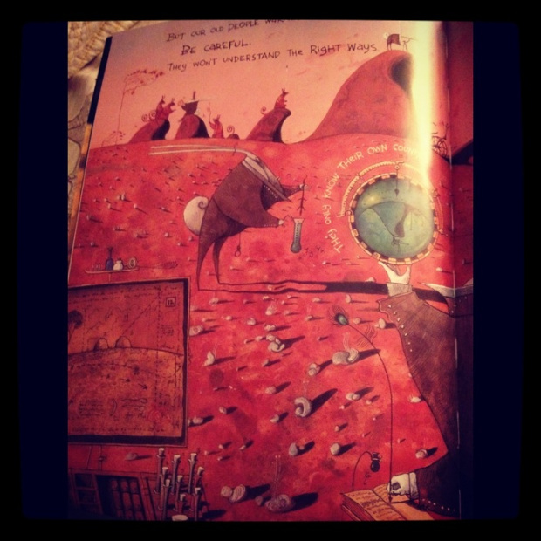
The rabbits after all looked high and mighty with their stiff, starched collars; pointed, upright ears; and their guns, cannons, high-tech weaponry firing in perfect formation – while the numbats carried spears and lived on trees and were subsequently outnumbered and outpowered.
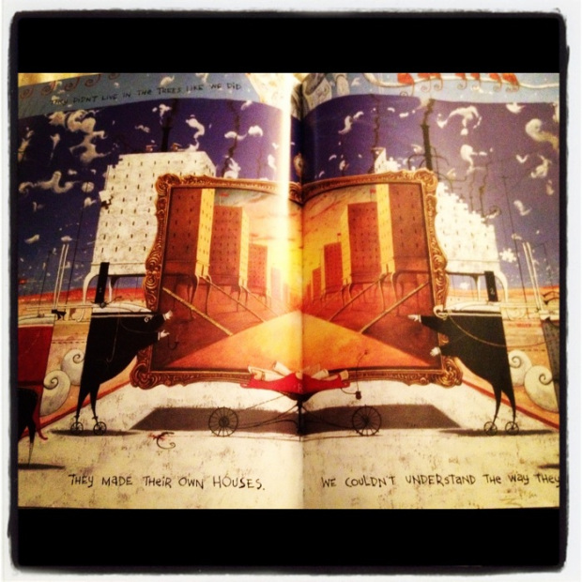
The straightforward, deceptively-simple retelling of Australia’s history is matched perfectly by Shaun Tan’s amazingly-stunning artwork that complements the narrative with dark black spaces, monochrome illustrations of how the rabbits have overtaken the entire country (“Rabbits, rabbits, rabbits. Millions and millions of rabbits. Everywhere we look there are rabbits.”), the sepia-toned undercurrents of loss and tragedy,
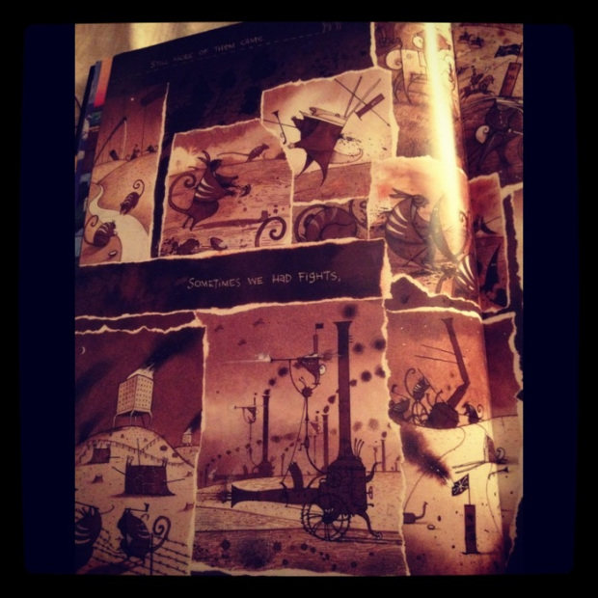
and the deliciously-surreal representation of all that is right and unjust, pure and sullied, and what it means to stand one’s ground (regardless of how shaky and small and crumbling it is). The book is a reminder, as well, of what we value as we cry out in anguish and claim ownership of what is rightfully ours – as one’s entire world is overtaken, captured, and judged to be less than what it is. My heart skipped a million beats when I opened this page that made me gasp out loud:
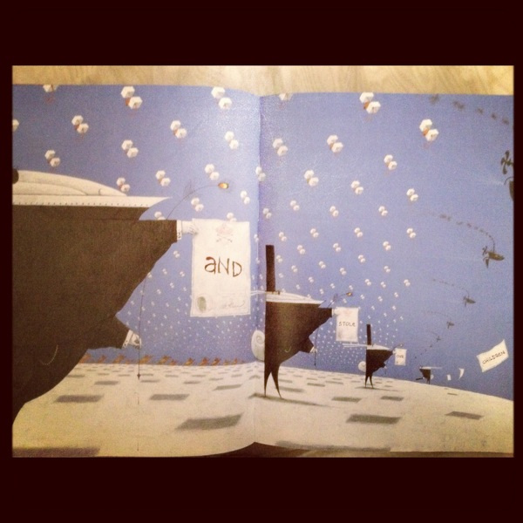
… and stole our children.
I was in Sydney when I watched the film, Australia, with Nicole Kidman and Hugh Jackman, and this clear snow-flurried page with the rabbits holding these signs just broke my heart – as it reminded me vividly of the film and the anguish that I witnessed then.
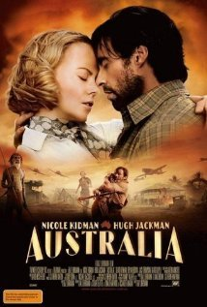
This is one of the most powerful picture books I have read this year. Teachers would have a field day integrating this with their social studies or history class, playing with the metaphors and the allegories, as they struggle to understand history from multiple points of view. For those who want more resources to understand the story line and the allegory better, here is an incisive scholarly piece by Brooke Collins-Gearing & Dianne Osland as published in The Looking Glass: New Perspectives on Children’s Literature.
If you are expecting a neat and fine resolution, with all ends deftly tied – then you’d have to think again. I normally don’t post spoilers here, since I don’t want to ruin the book’s experience for you, but I simply can’t help but quote this plaintive cry found at the end of the book:
Where is the rich, dark earth, brown and moist? Where is the smell of rain dripping from the gum trees?
Where are the great billabongs alive with long-legged birds?
Who will save us from the rabbits?
Here is a video clip from Youtube as inspired by the book. Let me know what you think of it.
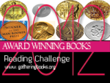Picture Book of the Year – The Children’s Book Council of Australia
AWB Reading Challenge Update: 65 (35)
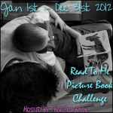
Picture Book Challenge Update: 69 of 120
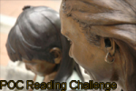
PoC Reading Challenge Update: 26 (25)
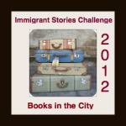
Immigrant Stories Challenge Update: 13 (6)
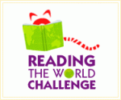
Reading the World Challenge Update: 5 of 7, nonfiction/allegory, Australia
http://gatheringbooks.org/2012/07/11/the-rabbits-by-john-marsden-and-shaun-tan/ - this has the youtube links on it

The Rabbits – Teachers Notes
http://www.thearrival.com.au/downloads/TG_TheRabbits.pdf

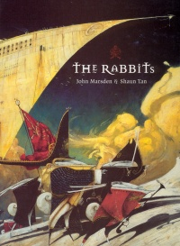 | The Rabbits.  John Marsden. Illustrated by Shaun Tan.  Vancouver, BC: Simply Read Books, 2003.  32 pp., cloth, $23.95.  ISBN 0-9688768-8-9.  Subject Headings:  Rabbits-Juvenile fiction.  Imperialism-Juvenile fiction.  Grades 2 and up / Ages 7 and up.  Review by Sylvia Pantaleo.  **** /4

The Rabbits is a compelling and disturbing allegory of colonization, industrialization and population growth. Many reviewers have used the word allegory to describe the book, but Shaun Tan, the illustrator, describes the book as a metaphor. Because Marsden is Australian, some have interpreted the story as the invasion of Australia by Europeans. However, the fundamental themes of the picture book are pertinent to humans throughout the world.

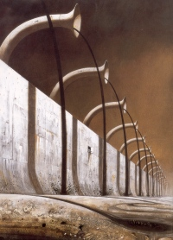
Text on the first verso reads, "The Rabbits came many grandparents ago." Initially, the inhabitants are tolerant of the newcomers, stating that, "At first we didn't know what to think. They looked a bit like us. There weren't many of them. Some were friendly." However, the elders' warning foreshadows the demise of the indigenous creatures and their land. As Rabbits continue to arrive in new and different ways, the original inhabitants begin to express concerns. A feeling of helplessness descends as the invaders take over and the illustrations communicate the imminent doom. On one double-page spread, Tan uses monochromatic colours to depict the conflict between the factions and the powerlessness of the native creatures. The collage-like appearance of this particular double-spread exacerbates the bleakness of the inhabitants' futures.
The Rabbits conquer the indigenous creatures. "We lost the fight." Tan juxtaposes the defeated native animals below the ground in bondage with the Rabbits above ground, their flags covering the land. The Rabbits continue to exploit the inhabitants and damage the environment. They commit the ultimate cruelty by stealing the children of the indigenous animals. An industrialized scene depicts the new status quo and the words "Might = Right" is inscribed at the bottom of a statute.
The Rabbits' legacy: destruction, desolation and despair. The book ends with the ultimate question, "Who will save us from the Rabbits?"
The text is minimal, yet the paucity of words is extremely effective. Tan uses colour and size symbolically in his stylized illustrations and the synergy between the text and illustrations is powerful. Many symbols are used throughout the text - the design on the Rabbits' flag, the clocks, and the arrows. The serenity of the end papers that depict waterfowl in a natural habitat are in stark contrast to the other illustrations in the book.
The Rabbits, first published in 1998, won the Australian Children's Book of the Year award in 1999. It also won the CBCA Picture Book of the Year Award. The Rabbits is an outstanding and sophisticated picture book that challenges and engages readers on multiple levels.
Highly Recommended.
Sylvia Pantaleo is an Associate Professor of Language Arts in the Faculty of Education at BC’s University of Victoria.

http://www.umanitoba.ca/outreach/cm/vol10/no19/therabbits.html

The Rabbits – John Marsden, illustrated by Shaun Tan
February 12, 2010 ~ Polly
I “met” Shaun Tan in the Byward Market in Ottawa when I was waiting for someone at the bookstore, and developed a serious crush on The Arrival, a story about immigration told entirely in pencil drawings. Then I learned about The Rabbits. And Tales of Lost Suburbia. And all of his other books, each more amazing than the last. In fact, I co-own all of them, thanks to a gift of a “complete set”. The set is “complete” until more books are published, and then I will just have to go out and re-complete it.
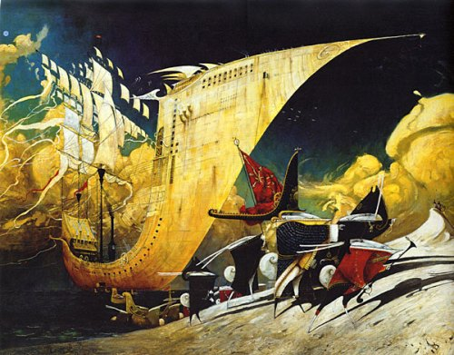
The Rabbits is a book about colonialism and its attendant evils (particularly environmental and cultural destruction), carried out with vigour and innocence by The Rabbits, who land in Australia and proceed to overrun it. Ecological history and human history meld. You could say that it’s an obvious metaphor, or you could say that it’s a brilliant parallel. I say “brilliant”.
Marsden uses words sparingly, and with effect. The sentences are clean and simple – there is dignity in them and a quiet despair. Tan, on the other hand, does not hold back with his illustrations. Sometimes simple, sometimes filled with activity, each one covers both pages. They are large, they are art, and in their colour and content they convey the various moods of Marsden’s text.
Tan has a gift for using unusual shapes to convey strangeness or making the strange seem almost natural (he also does this in The Arrival). The Rabbits look so…strangely familiarly Victorian (perhaps only familiar to colonials?)…with their machines, their high collars, their wig-like ears, their monocles and perambulators, their dark suits and long dresses, their hugs chests and tiny feet. Their Australian counterparts seem more real. Less strange. The world of pre-Rabbit Australia is serene and natural; post-Rabbit Australia is a contorted cacophony.
I’m not going to lie: it’s a scary book. It ends with tough questions, none of which have answers (ex. Who will save us from the Rabbits?). So if you like to know the answers, this may not be the book for you. But it is a book for me, and I’m glad to have it…especially so as it is extremely difficult to get your hands on it in North America and it more or less had to be special-ordered through Australia (or something ridiculous like that). I don’t know for sure, I just know that of the “complete set”, this book was delivered nearly a month after all of the others had arrived. It was well worth the wait.
I think The Rabbits is appropriate for people of many ages because although there aren’t many words, this book generates a lot of thought and questions, and older readers might have a better understanding of “Rabbits aren’t actually scary and bad, they are just a symbol.” The illustrations also use techniques (simplicity, complexity, organization of shapes and – unless I am mistaken – are done in different media) that could be appreciated by a budding artist, and the book has a message that people of all ages can appreciate. It is one of my favourite Shaun Tan books.
Favourite Line: At first we didn’t know what to think. They looked a bit like us. There weren’t many of them. Some were friendly.
Reading Ages: 5 and up.
Rating: A
https://vickyandpolly.wordpress.com/2010/02/12/the-rabbits-john-marsden-illustrated-by-shaun-tan/

The Looking Glass : New Perspectives on Children's Literature
Open Journal Systems
Journal Help
User
Top of Form
Username
Password
Remember me
Bottom of Form
Top of Form
Bottom of Form
Journal Content
Top of Form
Search
Search Scope
Bottom of Form

Top of Form
Bottom of Form
Browse
- By Issue
- By Author
- By Title
- Other Journals
Font Size
Make font size smaller Make font size default Make font size larger

Information
- For Readers
- For Authors
- For Librarians
- Home
- About
- Login
- Register
- Search
- Current
- Archives
- Announcements
Home > Vol 14, No 2 (2010) > Collins-Gearing
Alice's Academy

Caroline Jones, editor

Who will save us from the rabbits?: rewriting the past allegorically
Brooke Collins-Gearing & Dianne Osland

Brooke Collins-Gearing is a Murri woman who teaches in Children's literature and Indigenous literature at the University of Newcastle. Her research has focused on representations of Aboriginality and non-Aboriginality in Australian children's literature.
Dianne Osland lectures in English Literature at the University of Newcastle, Australia, and her publications include work on the problems of identifying and interpreting metaphor in fiction. She is currently engaged in research on reading practices and cultural change.

In 1992, the Australian High Court recognised that the Murray Islanders held native title rights over their land, effectively debunking the doctrine of terra nullius. This became known as the Mabo Decision, as the key plaintiff was Eddie Mabo, a traditional custodian of the land. The Mabo Decision has been the most influential legal decision in this country in defining the rights of Indigenous Australians in a “post-colonial” society. Hence, pre-Mabo and post-Mabo have come to signify the strong colonial framework before 1992 and the legally altered one after the decision. But what Larissa Behrendt terms a psychological terra nullius continues to pervade non-Indigenous representations of history and colonisation (Behrendt 20). We argue in this paper that Australian children’s literature, in particular, is still coming to terms with this psychological terra nullius, leading to a clash of pre-Mabo metanarratives of settlement and post-Mabo awareness of invasion and dispossession. Post-Mabo, non-Indigenous representations face the dilemma of acknowledging the presence of Indigenous peoples within colonialist frameworks built on the doctrine of terra nullius. That is, myths of white settlement have been, and continue to be, the basis for ideological, institutional and societal practices and beliefs that centre non-Indigenous cultures and relegate Indigenous cultures to the margins. We have chosen John Marsden and Shaun Tan’s 1998 multi-award-winning text The Rabbits as the focus of our examination because of its attempt to enter into and reflect recent national and historical dialogues about the construction of Australia’s history. In this text that deals explicitly with colonisation as a form of invasion and dispossession, we wish to examine Australia’s psychological terra nullius in terms of how it tries to create and invoke a post-Mabo collective identity.
The Rabbits was a timely publication, capturing – indeed, some claimed it was capitalizing on – the growing momentum of public sentiment that would eventually result in the newly elected Prime Minister’s 2008 apology to Indigenous Australians. A picture book with sparse text, The Rabbits is an allegorical representation of colonization. Small numbat-like marsupials [1] are dispossessed of their families, their communities, and their country [2] by invading Rabbits who have taken domestication to a level of ruthless efficiency: the Rabbits arrive with all the trappings of European culture – its clothes, agriculture, industry, and economy – and proceed to exploit the land to the point of devastation. And they steal the Numbats’ children. The text’s allegorical nature extends its ability both to create and to evoke colonial “memories” of invasion and dispossession. The Rabbits’ polemical nature, softened by the surreal images and spare text, informs the reader of the destructive power of colonisation.
While the images of the land and the creatures inhabiting it clearly locate the story in an Australian context, both the editorial blurb and Shaun Tan’s comments on his illustrations claim a broader reference. It is seen as “a rich and haunting allegory of colonization for all ages and cultures, told from the viewpoint of native animals” (The Rabbits publisher’s blurb) and a “partly allegorical fable about colonisation, told from the viewpoint of the colonised” (Tan “Shaun Tan”); internationally, readers seem to have little trouble generalizing beyond its regional particularity to identify a global significance in an allegory, not simply of colonization, but also of industrialization and ecological destruction more generally. It is a clever, earnest book that seemingly presses all the right buttons; it has won awards nationally and internationally (including the Children’s Book Council of Australia Picture Book of the Year in 1999), and it has quickly made its way into school curricula. But the simple language, striking illustrations, and Picture Book of the Year Award [3] do not disguise or divert attention from the contested dialogue about Australia’s history that it has entered into, nor from the problematic notions of identity (both for Indigenous and non-Indigenous Australians) that it evokes. The narrative constructs dichotomous representations of the “coloniser” (Rabbits) and “colonised” (Numbats): strong, weak; modern, ancient; civilised, primitive; centre, peripheral; conqueror, victim. Such binary oppositions are a legacy of pre-Mabo colonialist discourses in Australian children’s literature and reveal the text’s seemingly neutral colonialist discourses to be rooted in colonialist ideologies and legacies.
While the Rabbits in the illustrations look like Europeans (long ears excepted), walk upright like Europeans, and dress like Europeans, the marsupials look like small furry animals; they are, moreover, for the most part helpless bystanders. In Reading Race, Clare Bradford has argued that The Rabbits contributes to the history of “Aboriginalism” in Australian children’s literature: “the first-person account of the events of colonisation constructs the Indigenous as stupid and helpless, locking them into the posture of victims… the indigenous creatures who tell their story are naked and vulnerable, always the objects of the gaze of the colonising Rabbits” (113) and Aboriginality is further essentialized by the idea that Indigenous peoples are “primitive victims incapable of assuming agency in their own interests, unable to adjust or adapt to new and troubling times” ( 114). While we wish to extend the analysis of this essentialised and Aboriginalist version of Australia’s history as represented in The Rabbits, we also want to trace another consequence of white Australia’s “psychological terra nullius” on the depiction of colonial occupation. It is not just the representation of the “Numbats” that is problematic, but also the text’s struggle to depict and position the “Rabbits”.
The Rabbits overtly acknowledges that the landscape was inhabited before colonisation: its narrative, illustrations and themes attempt to deal with the coming of the Rabbits, their impact on the land and its original inhabitants (including the stealing of children), the losing battle the original inhabitants face, and the final question of a needed saviour. While the white Rabbits represent the British colonisers, the Indigenous peoples are represented by a nameless marsupial – variously identified by reviewers as bandicoots, tree kangaroos, even “bush babies”, but most closely resembling a numbat, a small, furry, white-banded creature, with a long bushy tail, that feeds mainly on termites and is currently classified, ominously enough, as an endangered species. The narrative is ostensibly from the original creature’s point of view, yet in the telling the colonized are perceived from the colonisers’ point of view, and, in the illustrations and in the outcome, the overall impact is one of the destructiveness of colonisation and the potential demise of the colonised. It is a one way, linear master narrative of history and events, an allegory of the dominance of the colonisers, their slow destruction of the land and its creatures and of the experience of loss, sickness and surrender by those who have been colonised. The Rabbits arrive, they conquer both the landscape and the “Numbats”, and the “Numbats” are powerless to fight against them.
If we apply Behrendt’s idea of psychological terra nullius here, we can see how the text struggles to subvert pre-Mabo narratives of Australia as an empty landscape and replace it instead with a narrative of invasion and dispossession. Non-Aboriginality is constructed on agrarian, pastoralist and scientific superiority, that is, the land was seen as empty because it was not being used the way the colonisers believed it should be. This belief provided justification for the taking of Indigenous land but the text somewhat subverts this by showing how the colonisers, with their superior ways, then destroyed the environment. The text struggles to come to terms with a non-Aboriginality that overpowered Indigenous Australians and a non-Aboriginality that acknowledges that dispossession. The post-Mabo struggle to place the Rabbits within the landscape sees them retain their power and force to the detriment of everyone and everything around them. The narrative acknowledges a post-Mabo awareness of dispossessing the original inhabitants, but is confined by a pre-Mabo collective memory of colonialist superiority that can conceive of only one kind of story to tell.
It is a story that is framed by the act of colonisation. Both the illustrations and the text start with the arrival of the Rabbits and end with the dominance of the Rabbits. According to Tan, this was a conscious choice: the cover illustration mimics a nineteenth-century painting by E. Phillips Fox depicting the arrival of European settlement according to “a familiar ideology, all about progress and destiny, the planting of flags and the arrival of legitimate historical narrative” (Tan, “Originality and Creativity”). But even, ostensibly, in telling this story from the viewpoint of the colonised, it perpetuates that colonialist ideology (particularly for readers – young and old – unable to recognise the ideological freight carried by the framing device). The narrative seems to suggest that this is the only version of history that needs to be told – anything before it is unnecessary. The telling of the tale “from the viewpoint of the colonised” thus becomes even more problematic, imposing on the original inhabitants of the land a decidedly Western temporal perspective. In contrast, Indigenous views of time as cyclical do not always separate these acts of invasion and colonisation from other important moments in Indigenous life and knowledges. That is, in concentric circles, colonisation, particularly the removal of children, remains close in time. It is not an event that happened in the past and is nearly or easily forgotten. But in The Rabbits, the original creatures appear only in relation to the act of colonisation; any notion of pre-existence is unnecessary and therefore pre-historical. This serves to reinforce the Western linear approach to time, movement from one period to the next and therefore movement further away from the original period: that is, the book starts with the arrival of the Rabbits and Numbats’ existence before this is now long gone and forgotten.
The illustrations also contribute to the narrative’s struggle to re-tell the story of invasion and ultimately reinforce the colonised perspective as the marginal one. Indeed, the Numbats are peripheral in most of the illustrations, and peripheral to the Rabbit’s society. In one particular, predominantly black and white, image, the Numbats are fringe-dwellers in the Rabbits’ world, homeless, on the grog (evidenced by discarded bottles), living rough out of cardboard boxes placed beneath a “Might=Right” sign. In the middle of the book there is a double page spread where the Numbats appear to be actively resisting the invasion of the Rabbits, “but there were too many” and the following page shows them curled up underground. In most of the illustrations and accompanying text the focus is on the Rabbits, their tools and power, their destruction of the land and all of its original inhabitants and their presiding dominance over the landscape: “Rabbits, rabbits, rabbits. Millions and millions of rabbits. Everywhere we look there are rabbits”. Towards the end of the book, all colour has slowly faded and blackness dominates the illustrations. The land changes from colour and abundance to “bare and brown” and empty. While the narrative tries to readdress pre-Mabo colonialist discourses that built on the doctrine of terra nullius, the illustrations contribute to the belief that if the land was not empty of “natives” before the arrival of the invaders, it became emptied of them soon after. The illustrations extend the pre-Mabo framework confining the narrative, only allowing them to position the Numbats as destitute and stricken. Outlines of the Numbats, curled in tight balls resembling the imprint of ammonite fossils, appear to be dotted underground, beneath the surface which is dominated by the Rabbits and their flags. The result is that the Numbats remain peripheral to the centred power of the Rabbits. What becomes important is what the Rabbits do, not what the Numbats do. Hence the text reverts to pre-Mabo colonialist structures and perspectives, even to the point of being reminiscent of colonial beliefs that the “natives” would eventually all die out.
While the narrative attempts to replace a pre-Mabo representation of “discovery” and “settlement” with a post-Mabo construction of invasion and destruction, it struggles to position the Rabbits in relation to both the Numbats and the land. The coloniser’s perspective is enforced in the text by the idea that the Rabbits conclusively defeated the Numbats. While the resistance of the “Numbats” is apparent in Tan’s double page illustration, in sepia-tinted cameos, of the Numbats sabotaging the Rabbits’ technology and engaging in sporadic or collective warfare, the following page blatantly states “We lost the fights”, as if subsequent ongoing fights for self-determination and sovereignty never occurred. By establishing the Rabbits as the dominant conquerors and the Numbats as the helpless victims, the Rabbits remain as invaders unreconciled with the landscape, yet it is their ideological and cultural norms that rule the land. If The Rabbits is portraying the history of contact, then it is a history that assumes that the Rabbits came out the winners and the Numbats still need saving. Throughout the text, in both the written narrative and the illustrations, colonisation is represented as a one way journey: the colonisers came in, they won the battles, they remain today the winners and those in positions of power: “They brought new food, and they brought other animals. We liked some of the food and we liked some of the animals. But some of the food made us sick, and some of the animals scared us”.
And what does this say about Aboriginal resistance and survival – then and now (to follow the linear idea of time as upheld by the text)? The images in the text attach colour and movement to the Rabbits’ side of the land, while the Numbats’ side is barren and brown. The barrenness of the Numbat’s world is compounded by their amorphous nonentity, they become little more than underground, fossilised skeletons. The use of a nameless creature to represent the Indigenous peoples is potentially a powerful technique, as Indigenous Australians did not refer to themselves as “Indigenous” or “Aboriginal” prior to invasion. However, the clumping together of all Indigenous Australians as one group disregards cultural diversity and the different experiences of colonisation. By establishing a colonial dichotomy of “us” and “them”, “Rabbits” and “Numbats”, the narrative also ignores the influence of other migrant peoples since colonisation, and the effects of intermarrying. [4] Furthermore, the representation of the colonised people as living in trees is, to say the least, unfortunate. In the spirit of terra nullius, the original inhabitants are hardly distinguishable from the other native flora and fauna as represented in the book, and one is reminded of section 127 of the Australian Constitution pre-1967, where Aboriginal Australians were not classified as people but as part of the flora and fauna. While the Rabbits look like people and act like people, the “Numbats” never cease to be animals, which pre-empts any notion that the Rabbits could learn or gain anything valuable from the colonised. The erasure of all but an impotent few Numbats erases also the opportunity that always existed, and still exists, for dialogue between non-Aboriginal and Aboriginal voices. By establishing such strict and explicit boundaries between the Rabbits and the Numbats (modern and “natural”, destructive and overwhelmed, winner and loser) the narrative struggles to re-write pre-Mabo settlement myths with a post-Mabo awareness that the land was wrongfully taken and the colonisers’ have built a whole nation on this theft. It attempts to raise and employ post-Mabo awareness and concepts, but, in fact, its passive ideologies simply re-inscribe the perceived hopelessness of pre-Mabo Indigenous peoples as subjugated and victimised.
While the text attempts to acknowledge some of the injustices done to the Indigenous peoples of Australia, it struggles to (re)define what this then means for the construction of “non-Aboriginality” and the colonisers’ relationship with place. In presenting the Rabbits as having the power to chain, ignore, represent and even speak for the Numbats, the narrative constructs the identity of the colonised as “the passive victim on display” (Chow 29). Raimond Gaita, in relation to coercive reconciliation, has argued that
Good-hearted people find it intolerable that just treatment of the powerless should depend on the generosity of the powerful – on their pity or even on their openness to an appeal to justice. Since at least 1788, the refusal to accept this has driven the rhetoric of human rights in a noble attempt to bestow dignity on the powerless by creating the illusion that rights are a kind of moral force field, a metaphysical barrier to the indignity of being ruthlessly crushed. I do not need your pity. I do not need your justice gratuitously given. I will stand on my rights. That is the spirit of it, a spirit of defiance. It is an illusion, I fear. Unless an appeal to rights has force to back it, its acknowledgement depends entirely on the spirit of justice in those to whom the appeal was made. (304-5)
Marsden and Tan’s narrative identifies the “native” as lack – “someone from whom something has been stolen” (Rey Chow 31). Chow, employing the work of Fanon, examines how postcolonial fiction constructs the image of the “other’s” subjectivity through the gaze of the oppressor: “The image, then, is an aggressive sight that reveals itself in the other; it is the site of the aggressed. Moreover, the image is what has been devastated, left bare, and left behind by aggression” (31). And it is here that we see the text’s struggle with mainstream Australia’s psychological terra nullius in full colour: the presence of the Numbats, their loss and their lack is what defines the presence of the Rabbits: “Our fascination with the native, the oppressed, the savage, and all such figures is therefore a desire to hold on to an unchanging certainty somewhere outside our own ‘fake’ experience. It is a desire for being ‘non-duped’, which is a not-too-innocent desire to seize control” (53).
The final page serves to reinforce the Rabbits’ need to seize control and Numbats’ status as helpless and demoralised creatures in need of rescue: “Who will save us from the rabbits?” The text reinforces colonialist assumptions that Aboriginal Australians cannot determine their own lives or their own futures. Potentially the ending could be read as exposing the continual control Western society has over Aboriginal peoples and their lives; however, presenting the Numbats as in need of a saviour denies their ability to save themselves. Centring the colonisers’ perspective, and effectively colonising the original inhabitants’ voice, silences the colonised, denying their ability to speak for themselves, refusing them the right to their own identity and history. And while some may argue that this is an accurate reflection of the history of colonisation, the text’s attempt to acknowledge a post-Mabo landscape of invasion and dispossession is undercut by pre-Mabo suppression of Indigenous voices, leaving no space to address injustices and denial of Indigenous rights. The final illustration of the intruding blackness upon the two figures – one rabbit, one original creature, sitting opposite each other on the edge of a pond that is the last remnant of the great billabong – is ambiguous at best. There is the potential to read this final image as a sign of hope, for the possibility of equal and shared communication between Rabbit and Numbat. However, the text implies that now both the Rabbit and Numbat need help – a saviour of some sort. It removes the option for the Rabbits to change their ways and acknowledge their power in what Gaita terms “the spirit of justice”: “The Aborigines have no power worth speaking of. If their voices are to be heard, if they dare speak from their hearts seriously to challenge our assumptions, be they assumptions of the Right or the Left, then it will be because we – the non-Aboriginal population – will have been moved by the spirit of justice to listen” (305).
As an allegory of colonisation, The Rabbits appears to be exposing the horrors of colonial exploitation, yet in its representation of “they came, they saw and they conquered”, even this post-Mabo perspective maintains the white metanarrative of history as war and winning. If the battle was fought and won (by the Rabbits) and the Numbats are only dwelling in the peripheral shade (both physically and historically), simply sitting back and waiting to be saved, [5] then this representation upholds the idea that modernity, civilisation, progress and the white man were unavoidable and remain so today, that the tools and knowledges of the Rabbits were too much for the poor nameless creatures to deal with, and therefore at some point progress was going to arrive.
The unspoken, and often unthinking, subtext of allegory is well-argued by James Clifford in his study of its use in ethnographic writing. In Writing Cultures, he points out that “Allegory (Gr. Allos, “other”, and agorevein, “to speak”) usually denotes a practice in which a narrative fiction continuously refers to another pattern of ideas or events. It is a representation that ‘interprets’ itself” (Clifford 99). In the case of The Rabbits, the text refers to patterns and ideas from Western colonisation and reinterprets not only what this means but the impact and power it has. So once again, the cultural framework for the narrative and its reader is a non-Indigenous, colonial, Western one. The power to construct the allegory and tell it has remained with “the Rabbits” and associated with this power is its intended interpretation and moral connotations. Clifford also states that “Allegory prompts us to say of any cultural description not ‘this represents, or symbolizes, that’ but rather, ‘this is a (morally charged) story about that’” (100). The Rabbits, in its depiction of the power of the Rabbits and their destructive power over the land, then becomes a morally charged retelling of the nation’s collective memory of colonisation. Pre-Mabo, the collective Australian psyche, and its doctrine of terra nullius, depended on being “morally” and legally right (the justification for invasion, protection, segregation, assimilation etc). Post-Mabo, the nation’s psychological terra nullius now has to come to terms with being morally “wrong”. However, the use of allegory, with its attenuation of the specifically Australian experience of colonisation, encourages selective blindness and political forgetfulness. The specific metaphor of colonisation (in this instance a rabbit plague) carries with it assumptions about the actual process – in this instance, as an unavoidable and essentially amoral natural phenomenon (what could be more natural than breeding like Rabbits?) that efface realities that can then be ignored.
Read as an allegory of colonisation, The Rabbits relocates the significance of the narrative beyond the specific context in which the story takes place, so that the particular and personal are appropriated and diminished, extinguishing a sense of personal investment and responsibility in the specific Australian context. It is a psychological terra nullius of a particularly insidious kind, emptying the land of meaning except as it “stands for” a bigger picture and larger historical, economic and environmental issues. The allegorical nature of the text and its embedded moral attachment also imply a “right” reading of the text. Allegory does require an active reader: the connections between the narrative and symbolic levels may be obvious, but they still need to be made by the reader ─ though the age at which children acquire the metaphorical competence to make such connections without guidance is still hotly debated. But more so than in other types of imaginative fiction, once the connection is established, interpretative options are severely curtailed. Tan denies that the book is didactic, arguing that “It’s up to the reader to draw whatever meaning they wish” (“Originality and Creativity”), yet reviews of the book that are critical of its heavy-handedness (most obvious, perhaps, in its reference to stolen children, which Tan seems to be trying to disengage from its jarringly literal historical context by an illustration that sees the children carried off in squadrons of box-kites) attack it for its “political correctness”, which implies not only a “closed” interpretation of the text but a “morally charged” one as well. The post-Mabo perspective relies on an allegory based on a pre-Mabo cultural framework that silences the possibility for Indigenous voices to engage in a dialogue with non-Indigenous ones.

Notes
1. For the purposes of this paper, the nameless creatures in the text will be referred to as numbats, which they most closely (though not exactly) resemble.
2. Prime Minister Rudd’s “Apology to Australia’s Indigenous People” makes specific reference to “the removal of Aboriginal and Torres Strait Islander children from their families, their communities and their country” (Address to Parliament 13th February, 2008).
3. The book advertises itself as suitable “for all ages, all cultures” (back cover), though Tan claims it was “originally conceived as a book for older readers” (“Shaun Tan: Picture Books”).
4. The analogy of colonisation to an invasion of rabbits not only disregards the cultural diversity of generations of colonisers but also glosses over instances of a more malevolent dispossession. Not all of the colonisers were instruments of merely collateral damage in their destruction of the Indigenous population in pursuit of economic imperatives. Some meant to do it.
5. Unsworth and Wheeler, in their positive analysis of The Rabbits (in which they refer to the original inhabitants as bandicoots), identify the way in which this passivity informs the language: “In several of the beginning illustrations the bandicoots are seen holding their spears just watching the rabbits. The rabbits, however, are seen as very active right from the start, driving, studying and measuring. This is mirrored in the text by the agentive roles taken by the rabbits and the bandicoots in relation to the kinds of processes represented by different verbs. The rabbits have active agentive roles with verbs like “made”, “brought”, “came”, “spread”, “ate”, “chopped” and “stole”. The bandicoots are less involved with words of action and more involved with communicative and mental process verbs like “warned” and “liked”. When they are involved in action, it is significantly negative – “lost”.” (72).

Works Cited
Behrendt, Larissa. Achieving Social Justice: Indigenous Rights and Australia’s Future. Annandale, NSW: Federation Press, 2003. Print.
Bradford, Clare. Reading Race: Aboriginality in Australian Children’s Literature.Carlton, Vic: Melbourne UP, 2001. Print.
Clifford, James and George E. Marcus (eds). Writing Culture: The Poetics and Politics of Ethnography Berkeley: University of California Press, 1986. Print.
Chow, Rey. Writing Diaspora: Tactics of Intervention in Contemporary Cultural Studies. Bloomington, IN: Indiana UP, 1993. Print.
Gaita, Raimond. “The Moral Force of Reconciliation”. In Coercive Reconciliation: stabilize, normalize, exit Aboriginal Australia. Ed. Jon Altman and Melinda Hinkson. North Carlton: Arena Publications, 2007. Print.
Marsden, John and Shaun Tan. The Rabbits. Sydney: Lothian, 1998. Print.
Rudd, Kevin. “Apology to Australia’s Indigenous People”: Address to Parliament 13 February 2008”. Transcripts. Prime Minister of Australia. 2008. Web. 20 Feb. 2008.
Tan, Shaun. “Originality and Creativity”. Paper Presented at the Joint National Conference of the Australian Association for the Teaching of English and the Australian Literacy Educators’ Association (Hobart, Tasmania, Australia, July 12-15 2001). Web. 12 Feb. 2009.
---. “Shaun Tan: Picture Books”. Web. 12 Feb. 2009.
Unsworth, Len and Janet Wheeler. “Re-Valuing the Role of Images in Reviewing Picture Books”. Reading 36.2 (2002): 68-74. Print.

Brooke Collins-Gearing and Dianne Osland

Volume 14, Issue 2, The Looking Glass May/June, 2010
Site design and content, except where noted, © The Looking Glass 2010.
"Who will save us from the rabbits?: rewriting the past allegorically" © Brooke Collins-Gearing and Dianne Osland, 2010.
Send general correspondence regarding The Looking Glass c/o The Editor (editor@the-looking-glass.net)

The Looking Glass: new perspectives on children's literature
https://www.lib.latrobe.edu.au/ojs/index.php/tlg/article/view/227/225

Passionate about picturebooks
Welcome to my blog about picturebooks in ELT.
“A picturebook is text, illustrations, total design; an item of manufacture and a commercial product; a social, cultural, historic document; and foremost, an experience for a child. As an art form it hinges on the interdependence of pictures and words, on the simultaneous display of two facing pages, and on the drama of the turning page.” (Barbara Bader 1976:1)
My intention is to discuss picturebooks, in particular the pictures in them! Why? Because, in ELT we tend to select picturebooks because they contain words our students might know. I plan to write something a couple of times a month, sharing what I discover in my readings; describe new titles I come across; discuss particular illustrators and their styles and generally promote the picture in picturebooks.
From January 2008 to December 2011 I benefitted from a PhD research grant from FCT, in Portugal.

Wednesday, March 07, 2012

The rabbits came many grandparents ago
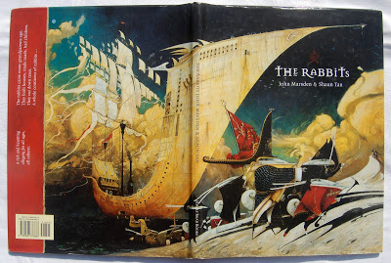
Front and back covers
The Rabbits by John Marsden and Shaun Tan is one of those picturebooks that leaves you gaping from a mixture of shock and admiration. It was the third picturebook illustrated by Shaun Tan to reach my bookshelf and to be featured on this blog. I've featured The Lost Thing and The red tree.
Both Marsden and Tan are Australians and through this picturebook make a very clear statement about cultural awareness, expertly creating an allegorical tale of colonialism. The Rabbits has been used in secondary schools since it was published in 1998 in areas of the curriculum that include English, Art and Technology, Philosophy, History, Geography and Environmental Studies. But has it been used in ELT? Let's see if I can convince the readers of my blog to consider its possibilities.
I've taken a photo of the front and back covers together - the image is so powerful: a huge ship with a pointed, harpoon-like prow. Napoleon-like creatures stalk around on pin legs, we can't quite make out what they are... though from the title they have to be rabbits. That strip of red on the back cover is actually a collage, a piece of red cloth, fraying at the edges. Could it be from the flags? Or from the invader's coat? The words on this fraying piece read:
"The rabbits came many grandparents ago.
They built houses, made roads, had children.
They cut down trees.
A whole continent of rabbits ..."
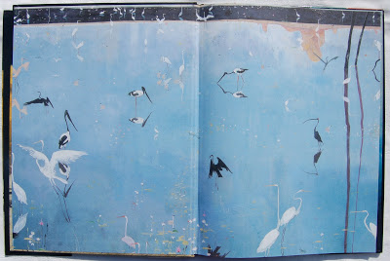
The front endpapers
The endpapers are a calm blue-lilac. Clean water, the home to graceful, long legged birds. What a contrast to the front cover. Is this the land these invaders have arrived at, that they will soon be invading?
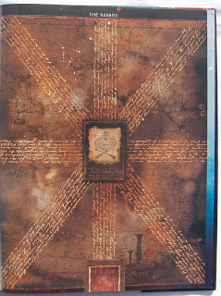
The half title page
The dark brown half title page imitates the format of a well known flag, with pen-inked squiggly writing and some sort of shield in the centre, superimposed over a map. You can peer and peer, but nothing can be discerned or made out.
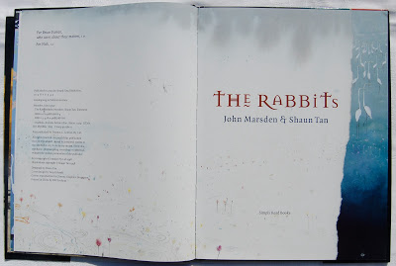
The title page comes next: a ripped sheet of paper, covering that blue-lilac bird-filled lake. We can see that some of the paper has begun to soak up the water, turning the white into a creeping grey, the birds are moving away from us, their backs are turned and they are all looking to the right, they've seen something we can't see yet. The white paper is both a cover as well as a vehicle for the pond life, as flowers are growing from its edges and dragon flies hum towards the dedications. The title font, as on the front cover, is not quite normal, the 'e' has a strange wave under it and the 't' is uncharacteristic. Are these letters from a past, letters that have changed over time to those we know and recognize today?
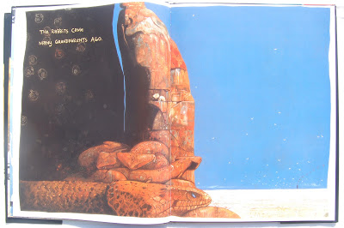
Opening 1
Opening 1 confirms our haunch, the birds are indeed fleeing, if the book had sound we would hear their calls of alarm, we would hear the snakes hiss in warning. What is that strange black chimney in the horizon? What are the fossil-like shapes in the dark cave behind the snakes? Does Tan want us to think of the time these fossils have taken to form? An age-old land. We read an invisible narrator's words, "The rabbits came many grandparents ago".
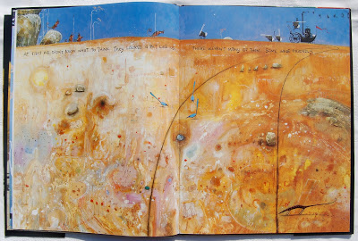
Opening 2
This illustration is of an immense land, home to tiny creatures, birds and insects. It has been marked by the wheels of a strange machine, which we can just make out on the horizon. Two worlds meet and wonder at each other: "They looked a bit like us ..." they were creatures, they had ears and tails, but they wore clothes and had strange machines... "There weren't many of them. Some were friendly."
And soon more came, and the old people warned us all... "they came by water." And we see the front and back cover as a spread, even more frightening now as we have begun the story, we know the significance of these strange creatures.
We are told and shown how different they are:
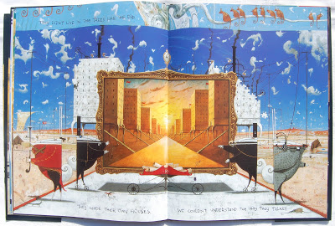
Opening 5
"They didn't live in trees like we did. They made their own houses." This particular spread gives us information in layers. The slightly lighter blue strip at the top is the original layer and belongs to the narrators. They are sitting in their trees, watching their world change. The darker blue is a superimposed layer, the result of the rabbits: we see both the buildings being built and what they will look like. The buildings are like puzzles, already spewing black smoke. Everything is mechanical, even the rabbits seem so, the symmetry emphasizing the mechanical way they changed the world.
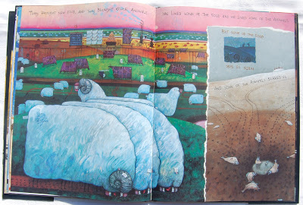
Opening 6
Not only were the rabbits' homes different, but "...they brought new food, and they brought other animals." The illustrations show us massive grass eating sheep, machines dressed in lambs' wool. Cows, already marked for the butcher's knife. The land is covered in these strange creatures, either in the fields or pilled high on spindly locomotives. More words tell us that "... some of the animals scared us." But that's not all, "... some of the food made us sick" (the last three words turned upside down, as though rolling over with belly ache). The illustration shows a rabbit giving a bottle to the aboriginal creature collaged upon another illustration of a dried up water bed, littered with flapping, gasping fish.
There was no stopping the rabbits, they spread across the country. There was fighting, "but there were too many rabbits"
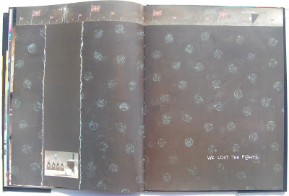
Opening 8
"We lost the fights." Those fossils we saw at the beginning, denoting an ancient world, dominated above by the rabbits' flags, the aboriginals, prisoners in their age old world, defeated below.
The atrocities continue: "They ate our grass. They chopped down our trees and scared away our friends... "
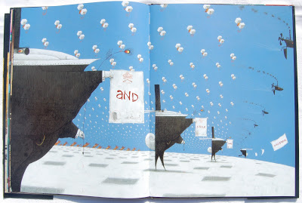
Opening 10
I find this spread the most shocking: hundreds of kites, with baby animals inside, being pulled by strange air machines. Mother creatures, as though dancing, hands raised towards their children, you can almost hear them moaning. And the rabbits, big and black, their vertical backs turned against the mothers. They have red and yellow eyes and the peacock feather pens mirror these evil eyes, dripping with the blood red ink they have just used to write on the certificates. These contain the verbal text of this page, each word on a separate sheet of paper, as though being spoken in jerks of distress, "and . stole . our . children."
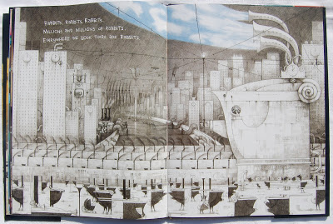
Opening 11
"... everywhere we look there are rabbits." The statue in recto, a large rabbit, the motto MIGHT = RIGHT. A grey automated world, polluted and literally filled with rabbits, right to the very edges of the page. Can you see the only aboriginal creatures on the steps of the statue? The fallen kite? The rabbits holding masks? The gigantic curved chimneys, sucking in the blue sky and puffy clouds? A curious image, a frightening image.
"The land is bare and brown and the wind blows empty across the plains. Where is the rich dark earth brown and moist? Where is the smell of rain dripping from the trees? Where are the lakes, alive with long legged birds?"
A final verso page shows a small cameo illustration against a black background. Two solitary creatures, a rabbit and an aboriginal.
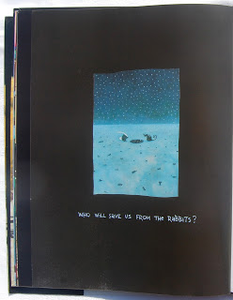
Back verso
"Who will save us from the rabbits?". The land is wasted, littered with bones, lost and broken pieces of machinery and empty bottles. A small water hole reflects the stars in the sky. Can we read this as an image of hope? Is there any hope left? If we turn again to the back endpapers, we return to the bird-filled lake of cool lilac-blue water. A distant memory? A possible future?
When I first saw this picturebook I got goose bumps, and every time I look at it I get that goose bumpy feeling. It's quite something. A simple verbal text alongside such complex visual images, makes for much interpretation. There are many issues here and therefore lots of opportunities for talk and discussion. If you are teaching English through history, could this picturebook be of use? If your programme includes such topics as multiculturalism, could it be of use? Or, if you happen to have a group of interested teenagers, keen to talk and discuss, keen to put the world to rights, could this book be of use? I'd say 'yes' on all three occasions.

